Intent-Driven AI-Native Precise Positioning-as-a-Service
Objective: To demonstrate an intent-driven AI-native precise positioning system delivered through ATSC 3.0 broadcast, where operator or service-provider intents such as maximize accuracy, ensure high reliability in challenging environments, or optimize ATSC 3.0 spectrum usage are automatically translated by the AI agent into real-time configurations of the positioning pipeline.
AI native: This PoC is AI-native because it uses intent-driven orchestration [FGAINN-I-097-R1], where high-level operator intents, such as achieving sub-10 cm accuracy, maximizing reliability, or minimizing ATSC 3.0 spectrum usage are automatically translated by the AI agent into real-time configuration of broadcast PLPs, RTK/bitmap correction parameters, and edge processing policies.
The system integrates:
- ATSC 3.0 broadcast delivery of GNSS correction data, maps, and bitmap-based positioning information
- RTK-style high-precision corrections via broadcast + optional unicast fallback
- AI-driven adaptive control of correction rate, message type, edge compute, and bandwidth allocation
The goal is to achieve:
- 3 to10 cm accuracy
- Robust reliability even in rural or obstructed zones
- Highly efficient spectrum use on ATSC 3.0 broadcast PLPs
https://github.com/tomojitakasu/RTKLIB
Phase 0 — Prep & data
Objective: get tools, sample data, and baseline running.
Tasks:
Install RTKLIB and confirm you can run a basic RTK solution on sample GNSS logs. Deliverable: .pos output files and a short report of baseline errors (no broadcast corrections).
Collect or synthesize RTK correction frames (RTCM) — RTKLIB sample RTCM or synthetic generator.
Create small bitmap tiles for a small area (e.g., 100×100 binary tiles representing “good correction coverage” or landmark masks).
Tip: Use small synthetic scenarios to start (single road, a few tiles).
motivation:
- A broadcast-based correction delivery reduces per-vehicle bandwidth/redundancy compared to unicast — making RTK for many vehicles more efficient.
- The system can support “mass-market” deployment of high-precision positioning for many vehicles, overcoming limitations of conventional NTRIP/unicast correction delivery.
- Broadcast corrections + appropriate encoding and error robustness can maintain sufficient correction quality across a range of receivers, even under mobility and varying reception conditions.
2. Key Performance Indicators (KPIs)
KPI | Metric
Positioning Accuracy | Horizontal/vertical error
Reliability | Valid correction availability
Correction Delivery Latency | Broadcast → UE decode
ATSC 3.0 Spectrum Efficiency | Bits/s/Hz for correction PLP
Service Continuity | Dropout rate (rural/urban canyon)

3. System Setup (ATSC 3.0 + RTK + Bitmap)
3.1 Reference Station Network (GNSS Ground Segment)
• Network of multi-GNSS (GPS, Galileo, etc.) reference receivers
• Continuously computes and outputs:
– RTK corrections (RTCM / MSM)
– Bitmap/grid-based error models (ionospheric, tropospheric, multipath probability tiles)
– SSR data for wide-area fallback
• Feeds correction data to the Broadcast Core with strict latency stamps

3.2 Broadcast Core
• Hosts the Intent-Driven AI-Native Positioning Orchestrator
• Responsibilities:
– Interprets high-level operator intents (accuracy, coverage, spectrum efficiency)
– Selects and configures ATSC PLPs for positioning
– Chooses optimal RTK vs SSR ratio
– Adjusts bitmap tile resolution and update frequency
– Controls redundancy, FEC, and repetition for robustness
– Coordinates compute distribution between cloud and Broadcast Edge
• Publishes packaged RTK + bitmap + integrity data to the Broadcast RAN

3.3 Broadcast RAN
• ATSC 3.0 transmitter creates dedicated PLPs for positioning:
– PLP-A: RTK correction stream
– PLP-B: Bitmap/grid-based error maps + integrity
– Optional PLP-C: Low-power IoT receivers or extended coverage
• Broadcasts all positioning content over ATSC RF to UEs and Broadcast Edge nodes

3.4 Broadcast Edge
• Performs localized enhancement and preprocessing, such as:
– Multipath prediction based on environment
– Local correction smoothing / gap filling
– Cache and refine bitmap tiles for low-latency access
– UE-specific fusion optimization policies
• Receives instructions from the AI Orchestrator for local processing parameters

3.5 UE / Receiver Layer (GNSS + ATSC Device)
• Dual-receiver UE with:
– GNSS chipset capable of RTK precision
– ATSC 3.0 demodulator for receiving PLPs
• Software stack includes:
– Bitmap/grid decoder
– RTK/SSR correction consumer
– AI-assisted fusion engine combining GNSS + IMU + broadcast corrections
• Produces high-accuracy position estimates even in weak-signal or high-mobility conditions

4. AI Agent Design
Inputs
Eg Intents:
- “Provide < 3cm accuracy”
- “Minimize ATSC spectrum usage”
- “Guarantee service continuity in weak-signal regions”
- “Support high-speed mobility”
Network & Environmental State:
- ATSC PLP load, SNR, FEC performance
- GNSS satellite visibility & geometry
- Multipath intensity (urban canyon)
- UE velocity
- Latency of reference station feeds
Quality Metrics:
- Correction age
- Position residuals
- Integrity indicators
- PLP packet loss
Outputs (AI-Controlled Parameters)
AI agent autonomously optimizes:
ATSC 3.0 Broadcast Parameters
- PLP bandwidth & FEC rate
- Bitmap tile resolution (coarse vs fine grid)
- Correction update rate (1–10 Hz)
- RTK vs SSR hybridization ratio
- Redundancy / repetition patterns
Positioning Algorithm Parameters
- Fusion weights (GNSS + IMU + corrections)
- Multipath mitigation thresholds
- Station selection / reference diversity
- Edge vs cloud processing decisions

5. Test Scenarios
Scenario 1: High-Accuracy Drone in Rural Area
Intent: “Guarantee sub-10 cm accuracy.”
AI increases correction rate, uses high-resolution bitmap tiles, boosts PLP reliability via stronger FEC.

Scenario 2: Low-Bandwidth Rural ATSC Coverage
Intent: “Optimize ATSC spectrum use.”
AI decreases correction bitrate, switches to lower-rate SSR/bitmap encoding, reduces PLP bandwidth.

Scenario 3: Urban Canyon Environment
Intent: “Maximize reliability.”
AI strengthens error grid resolution, bumps integrity updates, adjusts multipath prediction and fusion weighting.
Reference Architecture
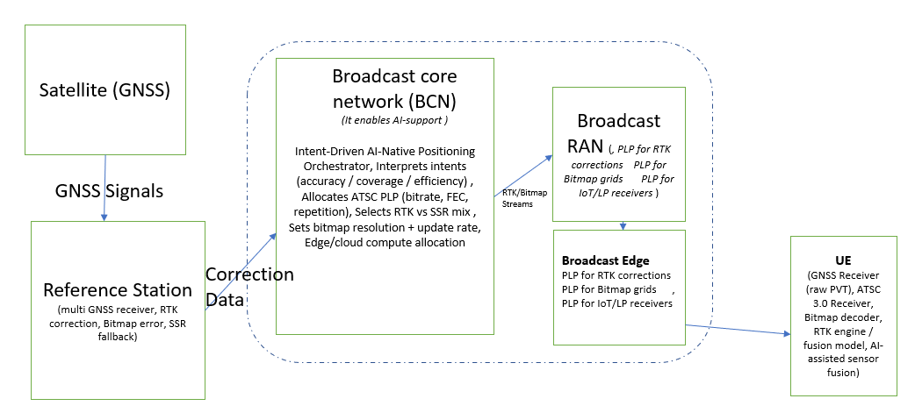

A. Reference ATSC 3.0 documents
Required | Why
A/331 | To deliver positioning data (bitmap, RTK corrections) over ROUTE/DASH datacast.
A/300 | For service creation & delivery model.
A/322 | If you want to vary PLP robustness for “maximize accuracy” intent.

B. Positioning-specific info you need
- RTK correction format (RTCM, MSM messages)
- Bitmap/feature-map data format
- Timing info: ATSC L1 signaling timestamps
- GNSS → Broadcast synchronization mapping (frame alignment)

C. AI-intent translation
Example intents:
- maximize accuracy → higher bitrate, more frequent RTK updates
- maximize reliability → robust PLP, lower code rate
- optimize bandwidth → compress positioning deltas, reduce frequency

D. Required APIs
- Generating ROUTE/DASH for non-video data
- Setting PLP parameters (if using a modifiable transmitter)
- AI agent config control for the pipeline

For PoC your codebase will include:

1. Broadcast-side modules
- ALP encapsulator (use libatsc3 or write Python/C++ wrapper)
- ROUTE/DASH packager
- Service (SLT/LLS) descriptor generator
- Transmitter control API (if dynamic PLP/power needed)
- AI agent (Python preferred)
  - Intent parser
  - Decision engine
  - Optimizer
  - Controller for ATSC parameters

2. Receiver-side modules
- ALP + ROUTE + DASH client
(libatsc3 or your own lightweight Python client)
- Positioning client

3. Orchestration layer
- REST/gRPC API exposing intents
- Real-time analytics module

